Spring 2026
CS 3503 Assignment – 5
Flip Flops & Sequential Circuits

- Complete the truth table for the following sequential circuit: (50 Points)

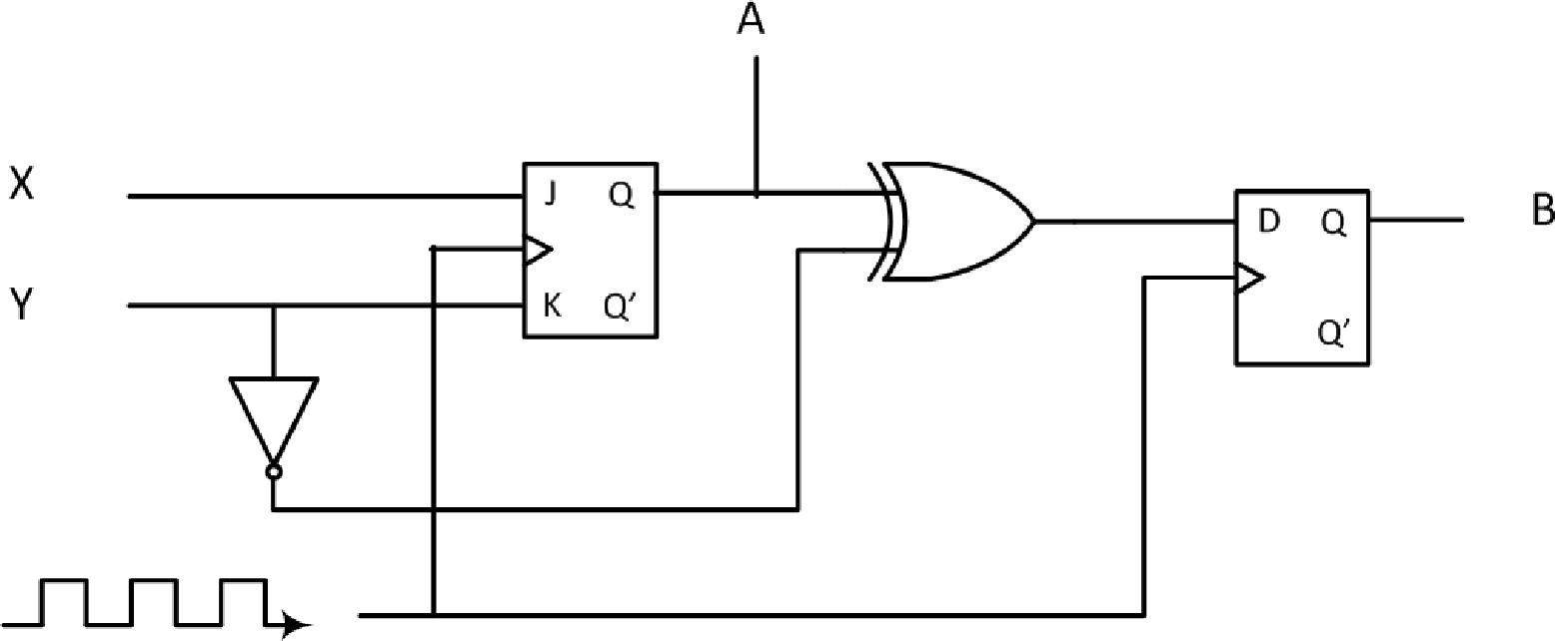

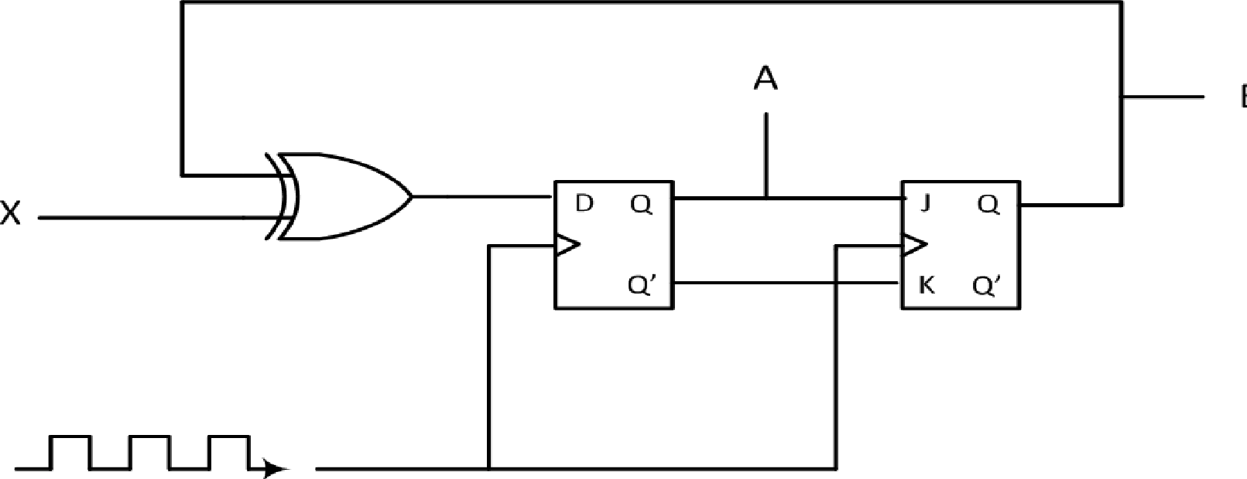

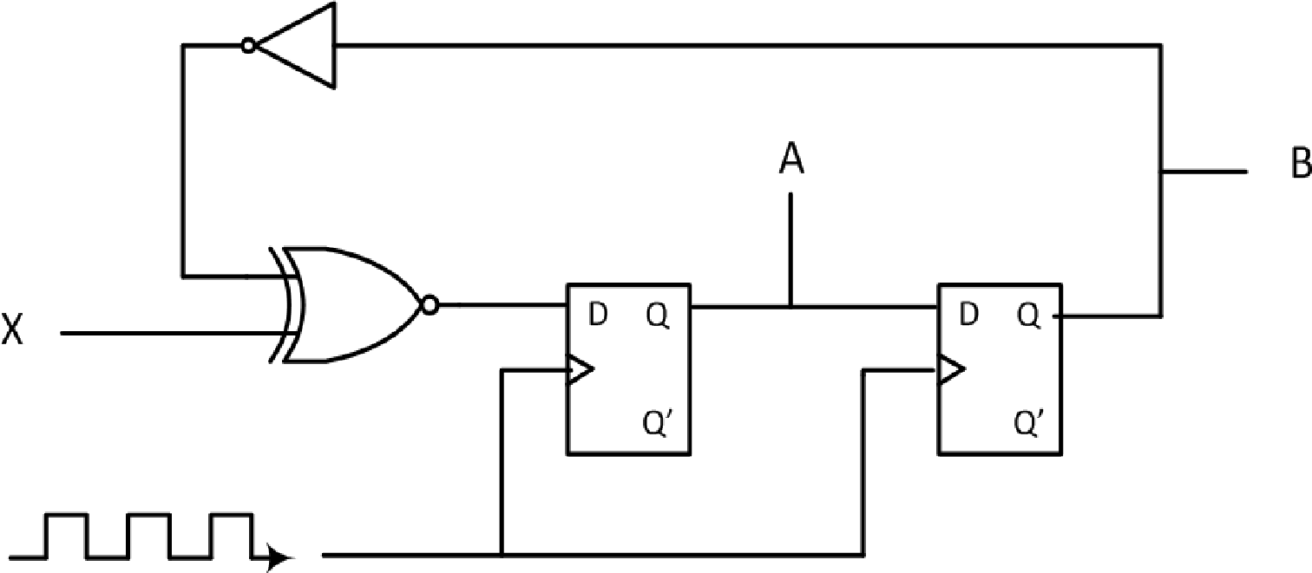

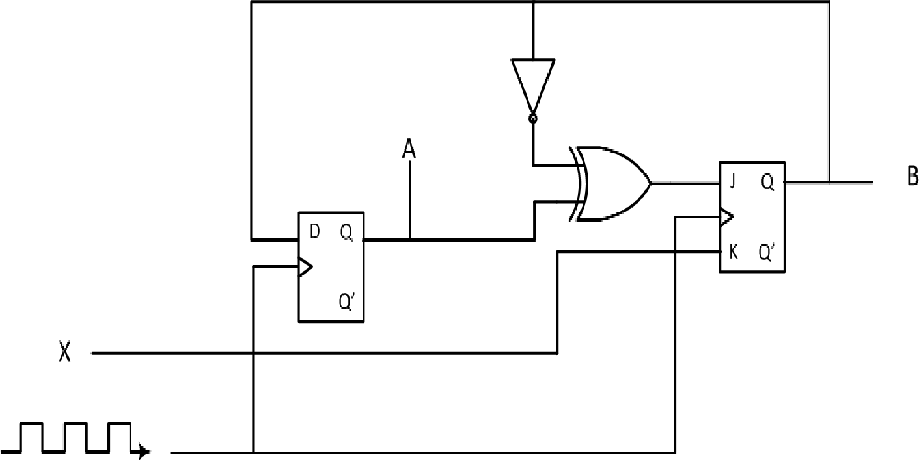

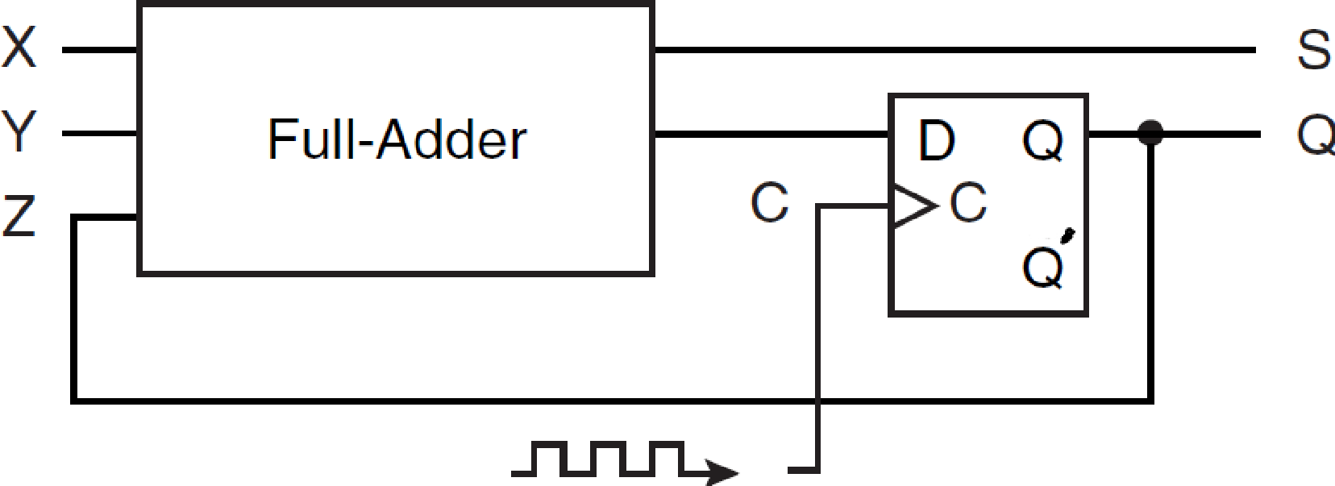

- A Null-Lobur flip-flop (NL flip-flop) behaves as follows: If N = 0, the flip-flop does not change state. If N = 1, the next state of the flip-flop is equal to the value of L. (15 Points)
a) Derive the characteristic table for the NL flip-flop.
b) Show how an SR flip-flop can be converted to a NL flip-flop by adding gate(s) and inverter(s). (HINT: What values must S and R have so that the flip-flop will be set and reset at the proper time when N = 1? How can you prevent the flip-flop from changing state when N = 0?)

- A Mux-Not flip-flop (MN flip-flop) behaves as follows: If M = 1, the flip-flop complements the current state. If M = 0, the next state of the flip-flop is equal to the value of N. (15 Points)
a) Derive the characteristic table for the flip-flop.
b) Show how a JK flip-flop can be converted to a MN flip-flop by adding gate(s) and inverter(s).
- Investigate the operation of the following circuit. Assume an initial state of 0000. Trace the outputs (the Qs) as the clock ticks and determine the purpose of the circuit. You must show the trace to complete your answer. (10 Points)
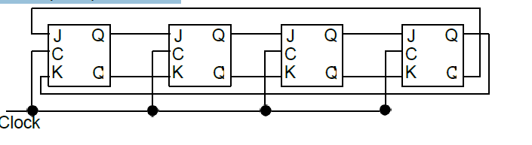
- A sequential circuit has one flip-flop; two inputs, X and Y; and one output, S. It consists of a full-adder circuit connected to a JK flip-flop, as shown below. Fill in the characteristic table for this sequential circuit by completing the Next State and Output columns. (10 Points)
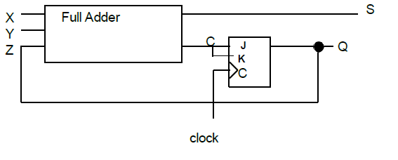

Answers: I did them on my tablet so I had to make a separate PDF file so they can be seen properly. I tried to do images but because of the amount i did it is distorted. It is much clearer this way. I will also attach it to the assignment upload, but just doing this so i follow the rubric.

Link: https://drive.google.com/file/d/1pRDg1PLH5lAJsstcqQ11DASV2ZVxZlY7/view?usp=drive_link

